NAME: SARANYA VIMALANATHAN ROLL NO: 240701620

USER INTERFACE AND DESIGN
Design a UI where users recall visual elements (e.g., icons or text chunks). Evaluate the effect of chunking on user memory.

RECALLIFY
Experiment - 1

REMINDER PAGE:
FRAME 1:

How the Reminder Page Uses Chunking
Chunking is basically a way our brain deals with information. It means taking a big piece of info and splitting it into smaller, easier bits, so we can understand and remember it better. The RECALLIFY reminder page uses this idea very well, like this:

1. Messages Are Clear and Stand Alone
- The reminder shows three short, encouraging messages, each on its own line.
- Keeping them separate helps people not feel overwhelmed and lets them really think about each message.

2. Smart Ways Information Is Grouped
- Motivation: It gives users positive thoughts to cheer them on.
- Building Confidence: Phrases like "Trust your memory" help people believe in themselves.
- Simple Encouragement: Saying "you've got this!" gives a little emotional boost.

3. How It Looks and Is Designed
- The clean popup design makes sure you focus only on the message.
- Text in the middle looks balanced and is easier to read.
- Having two buttons, "okay" and "close," gives users a clear choice.
- The soft blue colors make things feel calm and less stressful.

4. Making It Easy on Your Brain
- The reminder pops up right before you start learning, getting your mind ready.
- Short, clear messages mean you don't have to think too hard or feel tired by decisions.

5. Simple and Easy to Understand
- Sentences are short and to the point, so nothing feels complicated.
- Using active voice makes the message feel more direct and personal.
- There aren't any other distracting pictures or designs, so you just see the main message.

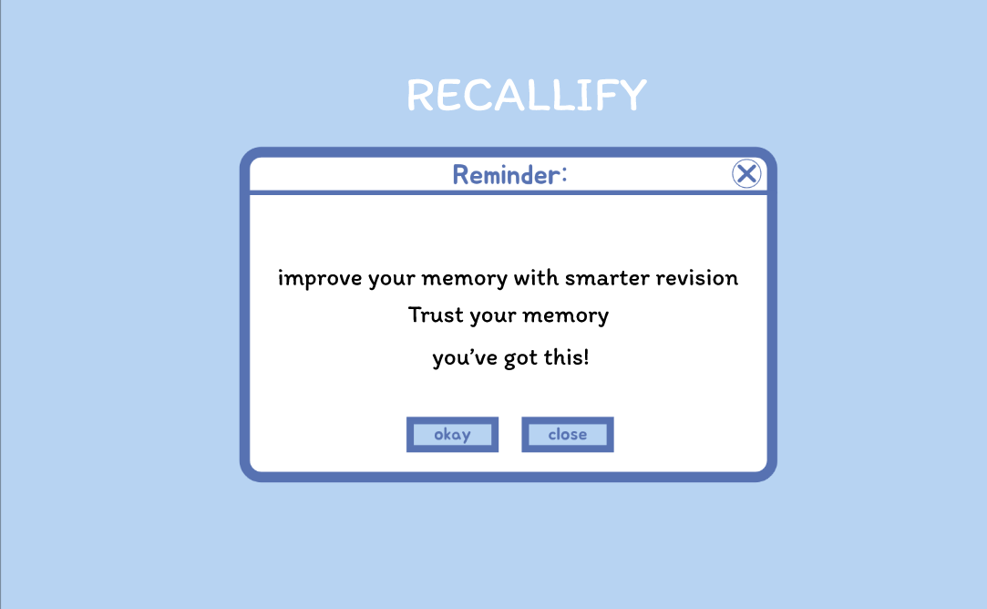

THE LEARNING PART (USING CHUNKS):
FRAME 2:

Looking at the Learning Screen - Where We Use Chunking
This screen is the learning part of the memory game. Here, people look at and try to remember marketing ideas in a set amount of time. Here's what makes up this screen:

1. Why This Screen Exists
- This is where you visually learn and start to put information into your head, getting it ready before you're tested on it.
- The "Chunking (Learn)" label tells you that this screen uses chunking ideas to help you sort and remember marketing concepts better.

2. Main Parts and What You See
- It has a clear title, "Marketing," written in big, easy-to-read letters.
- It gives a simple explanation: "Marketing is the process of promoting and selling products".
- You see "Product," "Price," "Place," and "Promotion," each with its own special icon.
- Each of these "P"s is put into its own round box, and they all look the same.
- The icons help you remember visually and link things in your mind more strongly.
- An example like "Ex: Apple uses sleek design and innovative ads" gives you a real-world idea.
- This example helps connect those big ideas to brands you already know.
- It clearly shows what to do next in the learning process.
- It's placed right where you can see it to lead you to the testing part.

3. How This Learning Part Goes
- First, you read and understand what marketing is.
- Then, you look at the 4 P's and organize that information in your head.
- The real-world example helps you understand things better by using something you know.

>> Content Section: Marketing Basics
>> The 4 P's of Marketing Framework
>> Real-World Example
>> Action Button ("Test Yourself >>")

- When you feel ready, you click "Test Yourself >>" to see how much you remembered.

4. What Chunking Does for Your Brain and Experience
- It helps your short-term memory by putting information into sensible groups.
- It makes things less overwhelming for your brain by grouping things clearly.
- It helps you spot patterns better because of the icons and how everything is laid out.
- It helps you learn more deeply by giving you examples that make sense in context.

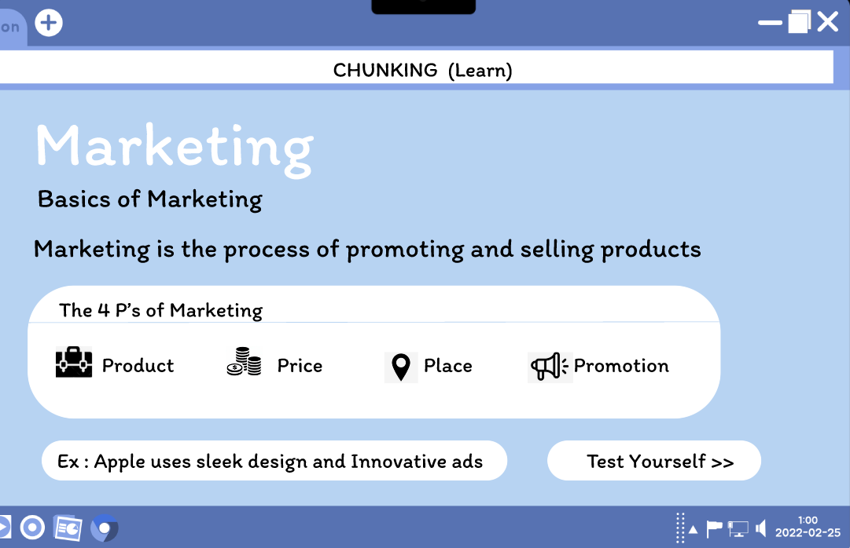

THE RECALL PART (QUIZ):
FRAME 3:

Looking at the Quiz Screen - Where You Recall Things
This screen is the quiz part of the memory game. Here, you try to remember and show what you understood about the marketing ideas from before. Here's what makes it up:

1. What This Screen Is For
- This is where you bring back memories and get tested. You show if you can remember the 4 P's of Marketing.
- The main point is to see how well chunking worked and how much information you held onto.

2. Main Parts and What You See
Title & Instructions
- The title "RECALL (Quiz) and RECOGNITION (Test)" clearly tells you what part of the game you're in.
- The words "Attempt the following:" tell you exactly what you need to do.
- The question, "Which of the following is NOT a P of Marketing?", makes you think and rule out answers to show what you know.

Multiple Choice Options
- You get four choices with radio buttons: Product, Promotion, People, Price.
- The buttons are clean and rounded, matching how things looked in the learning part.
- The right answer is "People" because it's not one of the usual 4 P's.

Recognition Testing Strategy
- It includes a trick answer ("People") to check if you really understood, or just memorized things on the surface.
- It checks if you truly grasped the 4 P's idea from the learning part.

3. How This Recall Part Works
- First, you remember the 4 P's of Marketing you learned: Product, Price, Place, Promotion.
- Then, you look at the four choices and figure out which one wasn't shown before.
- The trick answer "People" sees if you can tell apart what you learned from things that sound similar.
- You pick your answer and then move on to see your score.

4. What Your Brain and Experience Get Out of It
- It checks how accurate your memory is by comparing your answer to what you learned.
- It uses a trick answer to see if you really understood, or just thought you recognized it.
- The screen is easy to use, with clear radio buttons for making your choice.
- It keeps you involved by asking simple, straightforward questions.

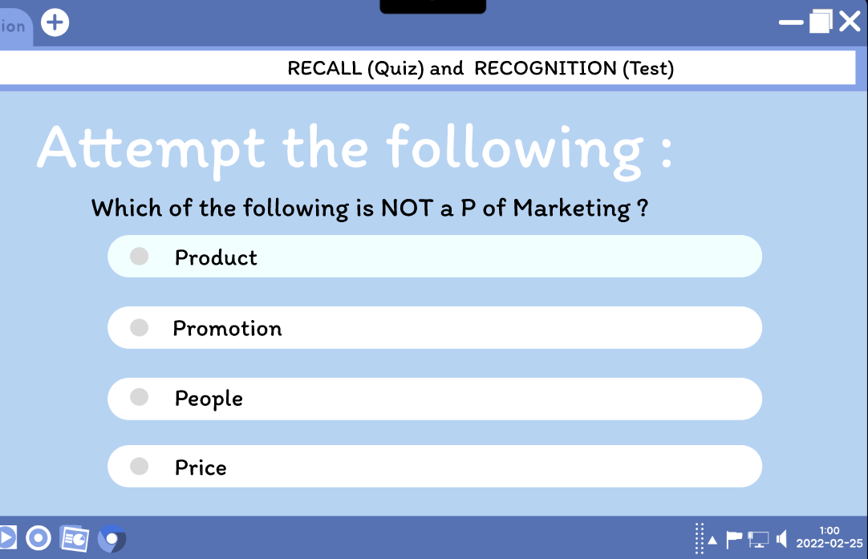

THE RESULTS PAGE (YOUR FEEDBACK):
FRAME 4:

Looking at the Memory Task's Results and Feedback Screen
This screen is where you see your results and get feedback after the memory task. You get to see how you did and decide what to do next.

1. What This Screen Is For
- It immediately tells you how well you remembered things with a clear score.
- It also gives a detailed look, showing what you got right and wrong.
- And it lets you keep learning with clear next steps.

2. Main Parts and What You See
Score Display & Progress Bar
- You'll see a big "Score: 10/10" with a happy "Good job!!" message.
- A bar shows your progress, making you feel good right away and showing what you've achieved.
- A perfect score means the chunking method worked really well for you.

Detailed Feedback Section
- "Correct: People" — this shows you which answer you got right.
- "Incorrect: None" — this confirms you didn't make any mistakes.
- Clearly sorting things out helps you understand how you did.

Action Button ("Recall and Retry >>")
- This button prompts you to practice again and really cement what you learned.
- It's placed right where you can easily find it.
- This helps with spaced repetition, which is a big deal for remembering things.

3. How This Part Works
- The system looks at the answers you picked in the quiz part.
- It figures out your score (like 10/10 here) and shows it clearly.
- You check the breakdown of your performance to see what you remembered well.
- You can choose to try the task again to make your memory even stronger.

4. What Your Brain and Experience Get Out of It
- Getting feedback right away helps you see how you're learning.
- Positive words like "Good job!!" make you feel more confident and motivated.
- A clear look at how you did lets you check your own progress.
- The option to retry encourages you to practice on purpose and really solidify memories.
- Things that look good and feel like a game make learning fun and rewarding.

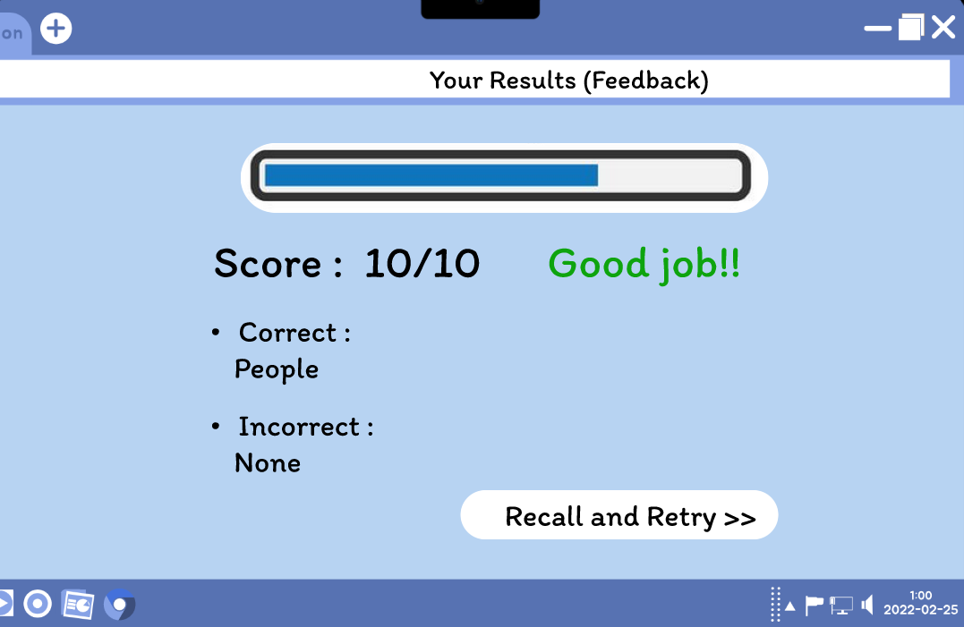

PROTOTYPE LINK:
https://www.figma.com/proto/FCL51LtOrzuVP91QlElkjt/Untitled?page-id=0%3A1&node-id=3-14&p=f&viewport=61%2C195%2C0.33&t=BwMqNapmSYT9ImHw-1&scaling=scale-down&content-scaling=fixed&starting-point-node-id=1%3A4

